
RAFFLES INSTITUTION
GIFTED EDUCATION PROGRAMME
ADDITIONAL MATHEMATICS

ASSIGNMENT 2

1. and are two sets and the number of elements in each set is shown in the Venn diagram. Given that , calculate
3
A
B
- the value of ,
- and .
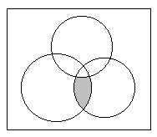
A
B
C
2. Write in set notation, the set represented by the shaded region.

3. Given that , and . List the elements of the following sets (you should draw a Venn diagram first):
(a) (b)

4. Given that , and , find the greatest and least possible values of .

5. Copy the Venn diagrams below and shade the sets accordingly.
(a) (b)
A
B
C
Y
Z
X

