
RAFFLES INSTITUTION
GIFTED EDUCATION PROGRAMME
ADDITIONAL MATHEMATICS

6.1 DEFINITION
A set is a collection of objects, numbers, ideas etc. The different objects in the set are called the elements or members of the set.
A set may be defined by using any one of the following methods:
(i) By listing all the members, for instance, and . The order does not matter and the elements are listed once only.

- By listing only enough elements to indicate the pattern and showing that the pattern continues by using dots ‘’. For instance, .

- By a description such as .

- By issuing an algebraic expression such as , which means “the set E contains the set of elements, x, such that x is an integer whose value lies between 2 and 7 inclusive”. (See Set-builder Notation below)

6.1.1 ELEMENTS
The elements of a set are the individual members of that set. For instance, if , the elements of A are the numbers and 11. So, since the number 2 is an element (or member) of A, we can write , where ‘’ denotes ‘belongs to’, ‘is a member of’ or ‘is an element of’.
On the other hand, the number 13 does not belong to the set A and so we can write .

6.1.2 SET-BUILDER NOTATION
Commonly used notation for sets on the real line:
is the set of real numbers
is the set of positive real numbers, i.e.
is the set of natural numbers,
is the set of integers,
is the set of positive integers,
Example:
(a) can be written as
(b) can be written as
(c) can be written as
(d) can be written as
(e) The set of positive real numbers less than 3 can be written as
In the above, ‘n’, ‘p’ and ‘x’ are dummy variables.

6.1.3 ORDER OF A SET
The order of a set is the number of elements contained in the set. For example, if , then we write .

6.1.4 TYPES OF SETS
(i) FINITE SETS
These are sets in which all the elements can be listed, such as .

(ii) INFINITE SETS
These are sets in which it is impossible to list all the elements. For instance, .

(iii) EMPTY OR NULL SET
A set with no elements is known as an empty set (or null set), denoted by or .
Example:

(iv) EQUAL SETS
Two sets A and B are equal if they have the same elements. This is written as . For instance, .

(v) SUBSETS
If all members of a set A are also members of the set B, then A is said to be a subset of B.
For instance, consider the sets Then,
A is a subset of C, written as .
Also, .
However, we note that . A is called a proper subset of C, denoted by .
Hence, If , then
If , then
Also, for any set A,

(vi) UNIVERSAL SET
The universal set for any particular problem is the set which contains all the available elements for the problem. Thus if the universal set is all the odd numbers up to and including 11, we write .

(vii) COMPLEMENT OF A SET
Consider and . We define the set which consists of all the elements not in P, so and is called the complement of P.
Hence, if is the universal set, the complement of P is the set .

6.2 INTERSECTION AND UNION OF SETS
6.2.1 VENN DIAGRAM
The pictorial representation of the relationship between sets is called a Venn diagram.
Example: and . can be represented by the following Venn diagram:
1
2
3
4
P
Q

Example: Consider , and
1
2
3
4
5
6
7
8
9
10
A
A

The above Venn diagrams illustrate two different ways of representing the sets. Instead of listing the elements in each set, we can write down the number of elements of each set as shown in the diagram on the right.

Note: If is a universal set and A is any set, then

In order to identify a set in a Venn diagram, we shade the region representing a set A as shown:
A

6.2.2 INTERSECTION OF SETS
The intersection of set A and set B is the set which contains all the elements that are elements of both set A and set B and is denoted by .
That is
A
B

Two sets A and B are disjoint
A
B

Example: A and B are two sets and the number of elements in each set is shown in the Venn diagram. Given that , calculate
3
A
B
(a) the value of x, (b) and .

Solution: (a)
(b)

6.2.3 UNION OF SETS
The union of set A and set B is the set which contains all the elements that are either elements of set A or set B or in both, and is denoted by .
That is

Venn Diagrams:
A
B
A
B
A
B

In general, for any set A and the universal set ,
and

Example 1: Let
Describe the members of the following sets:
(a) (b) (c) (d)
Solutions:

Example 2: Given that is the universal set and , in separate Venn diagrams, shade the sets:
A
B
A
B
A
B

(a) (b) (c)
A
B
A
B
A
B

(d) (e) (f)
A
B
A
B
A
B

(g) (h) (i)

Example 3: In the Venn diagrams below, shade the sets:
A
B
C
A
B
C

Example 4: , and . Find and .

6.3 SET OF REAL NUMBERS ON THE REAL LINE
The set and can be represented graphically on the REAL LINE as shown below. With the aid of the graphical representation, the sets and can be obtained as shown below:

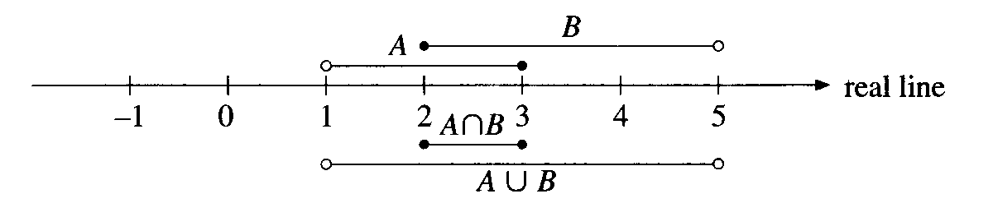

From the above, it is clear that and .

6.4 SET OF POINTS IN A PLANE
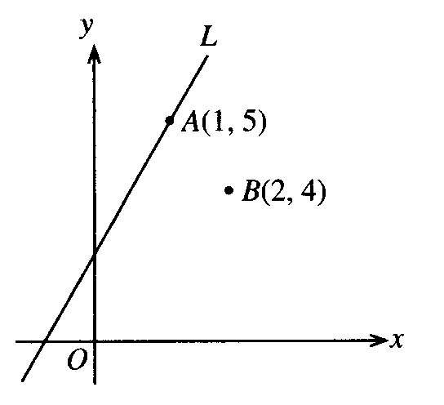
The set L denotes the set of points on the line in the Cartesian plane. So, . For example, since is a point on the line, . Since is not a point on the line, .

6.5 APPLICATIONS
Example: (a) G and H are sets of students who study Geography and History respectively. Using the letters G, H, set notation and to represent set members, write down an expression for the following statements:
- “x is a member of the set of students who study both Geography and History”,
- “x is a member of the set of students who study only History”.
Illustrate, by shading on a Venn diagram, the region that could lie in.
(b) There are 32 students in a class and each studies at least one of the subjects: Geography or History. Of these, 22 study Geography and 15 study History. By drawing a Venn diagram, find the number of students who study both History and Geography.

Solution: (a) (i) and . Hence .
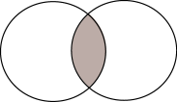
H
G

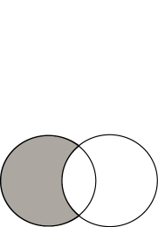
(ii) and . Hence .
H
G

(b) Let
and
Then
Let
x
G
H

Then

Hence there are 5 students who study both Histoy and Geography.

Practice

1. In a group of 20 students, 14 play badminton, 9 play table tennis and do not play either of the games.
- If , find the number of students who play both games.
- If , find the greatest possible value of .

Solution:
- Let ,
,
y
B
T
x
and .
If , we have
Thus the number of students who play both games is 3.

(b) has the greatest value when is the smallest.
5
B
T
x
9
Hence
Thus the greatest value of x is 6.

2. A group of students was given a choice to study the subjects – physics, chemistry and biology. The Venn diagram shows some of the information about their choices.
(a) Given that 30 students took physics and 25 students took chemistry, find
7
6
3
x
x
Chemistry
Biology
Physics
(i) the value of ,
(ii) the number who took physics only,
(iii) the number who took at least two of the subjects.
(b) Given also that 50 students were in the group, and each of them took at least one of the subjects, calculate the number who took biology only.

[Ans: 6, 14, 22, 9]

3. Of the 24 students in a class, 18 like to play basketball and 12 like to play volleyball. It is given that
and
.
Let and draw a Venn diagram to illustrate this information.
- Describe the set and express in terms of .
- Find the smallest possible value of .
- Find the largest possible value of .
[Ans: , 6, 12]

